**Plagiarism Checker X Originality Report**

Date

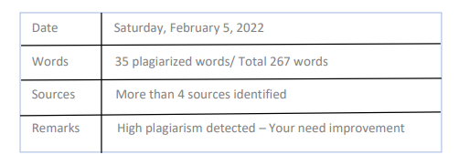

Plagiarism Quantity 4% Duplicate

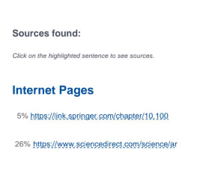

**Aim : Literature study on User centered problem**

**Paper 1:**

**Title : User center design of e learning User interfaces : A survey of practices**

**Author : Lingtan Mathari Hassani; Dana Indra Sensuse ; Ryan Randy Suryono**

Designing an effective user interface (UI) of e-learning system that has excellent usability is a crtical activity in e-learning development. Nowdays , a User Centered Design (UCD ) is a popular method used for development the user interfaces of e-learning of system and modules . The systematic literature review offer a helicopter view of state art applications of UCD and its impact e-learning system. This study reviewed 17 works of literature from 2015 until early 2020 identify how reaech in development projects applied UCD and its impact on usability development system applied UCD differently in the system and user involvement . The prototype’s iteration is done by comparing the SUS questionaries performance socre of the first and second iteration has successfully iteration The algorithm The most popular method integrated with the UCD are questionaries, interviews , high fidelaity prototyping and usability testing.

The study also found that the some of projects that the UCD involving the user in multiple phase produced a design with good usability . Futher more usability , this study suggests that both learners and subject matters experts. The effective systematic literature review offer a helicopter view of state art applications of UCD and its impact e-learning system. This study reviewed 17 works how reaech in development projects applied UCD and its impact on usability development system applied UCD aplications. E-learning makes learning more flexible , promotes in interaction and enables self placed learning.

**Plagiarism Checker X Originality Report**

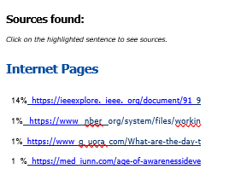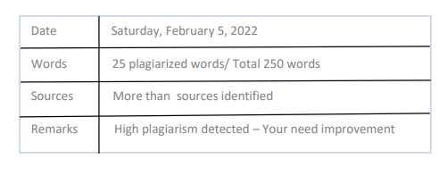 Plagiarism Quantity 3% Duplicate

**Paper 2:**

'

**Title : Layout design with a firely algorithm for user interface in a vehicle system**

**Author : Wang chen; Hao Yu; Xinyan Li; Longbo qu; Zhaoyang Mi**

With the advancement of science and technology the interaction between the occupants and user interfaces system is become more and more complicated . It is of great value to study the layout user interface system. Give the interface layout , this paper uses a firefly algorithm (FA) to optimize interface layout . First , this paper analyze the layout charateristscs of user interface and then abstarcts this problem and the second iteration has successfully iteration The algorithm The most popular method integrated with the system established the mathematical model where the object is to maximize the space accuracy . Finally this paper uses firely algoritm improves utilization of interface system

User interface is medium for inercation and information exchange between system and users . It realizes the conversion between the internal form of information and the form acceptable The algoritm layout , this paper uses a firefly algorithm (FA) to optimize interface layout. The user interfces emphasize humanized human computer interaction so it is necessary to design the layout of interfaces reasonably .

**Plagiarism Checker X Originality Report**



Plagiarism Quantity: 4% Duplicate



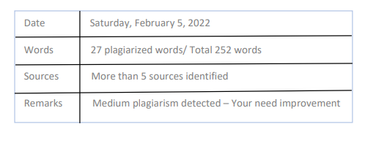

**Paper 3:**

**Title : UI-UX Design and analysis of Local Medicine and Medication Mobile based**

**Apps using Task Centered Design Process**

**Author : Muhammad Daffa Alfaridzi; Lenny putri Yulianti**

Indiegenous knowlge has been utilized by Indiegenous people for so long. Unfortunalty the process of coveying it to the people outside the circle is barred it tactit form. To transform it into manifestation , knowdge management system is needed . Elication of konwldege is needed to build a proper representation. A crowdsourcing and crawling based konwldge elication app is alsopropsed to do so. As it curcuial to satisfy user need and what they want to accomplish with the apps a task centered Was chosed. The step in the process consists conducting tasks and centered design planning , plagarizing, roughing out design process was choosen. The step in the process consists of conducting task and user analysis, choosing repsentataive task for task centeerd design process.,building a mock up and evaluating the prototype , interacting the design evaluating the protoype for all the iteations . The prototype’s iteration is done by comparing the SUS questionaries performance socre of the first and second iteration has successfully iteration .The system and its impact on usability development. The research successfully observed UI and UX design of konwdlge elication app that is viableIndiegenous people around the world have been practicing Indiegenous Furthermore it is the education and natural resuoce managemnent and other activities in the village community syste.